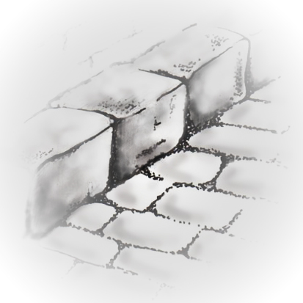
FRYER’S WHARF AND SLIPWAY
RESTORATION PROJECT
www.tinternvillage/villagegroups.co.uk

Report for Funders Feb 2014

Dear Pam

The phase of the project that your organisation generously funded has now been completed: namely to carry out a geotechnical survey for Welsh Water to enable them to relocate the Sewage Pumping Station and to assess the stability of the adjoining church wall.

The work was overseen by Mann Williams, Civil Engineers under the Direction of their regional Director Mr Pat Ruddock with on-site engineering supervision of Gemma Lockwood. The site works were carried out by Ground Investigations under the supervision of Marc Williams. ‘Church and Site Archaeological Services’ under the direction of Felicity Taylor provided an archaeological watching brief and as required under the terms of the Church Authority Legal faculty.

Elsa Wood, as chairman of the Fryer’s Wharf committee and Jim Hewitt, as consultant surveyor, attended the work at regular intervals.

The work on site was carried out during the week of November 25th -29th.
This comprised a window survey close to the church wall in the churchyard and above the slipway. Two 200mm bores were taken to a depth of 4metres in the churchyard and to 6metres above the slipway. A slit trench to a depth of 2m was also dug in the churchyard. The core samples and findings from the trench were analysed by Marc Williams, Gemma Lockwood and Felicity Taylor.

In addition, a trench was dug in the car park adjacent to the slipway to locate the positions of pipes and utilities that serve the existing Sewage Pumping Station. A Welsh Water representative attended site to inspect their underground apparatus.

A larger bore was carried out in the car park in the proposed location for the new pumping station. This bore went to a depth of 10.5m where the bedrock was located. The alluvial material and river gravel core samples were also taken for analysis. Water sampling of the borehole will continue over a period of time.

The work necessitated the closure of the Tintern Community Council car park for periods of time but the Tintern Community Council also local residents were informed well in advance so that alternative provisions for their car parking could be made.

All excavations and boreholes were backfilled and surface damage made good immediately after the work and to the satisfaction of the landowner.

The archaeological report was produced and lodged with the Fryer’s Wharf Committee on 7th February 2014.

The technical report from Ground Investigations and the report from Mann Williams were lodged with the committee on 27th January 2014.
These reports will enable Welsh Water to move to the design phase of the new pumping station and allows the Fryer’s Wharf Project to move closer to its objective of reopening the slipway.
Copies of the three reports are publically available and copies can be sent to you should you so wish.

We are currently drawing up a schedule of works with costings for the next stage of the project that will include removal of the old pumping station, clearance, repair, and maintenance of the slipway. This phase of project planning could take several months as it will depend on the pumping station design and preparation of the Welsh Water programme of works

The final bill for this stage of the project was £11,983.14 which we were able to meet with your grant together with the other match funding.

Thank you again for helping to support this part of the project and I shall keep you informed of the requirements for the next phase of demolishing the redundant Sewage pumping Station and reopening the slipway and assessing any repairs that may be necessary to the slipway or church wall.

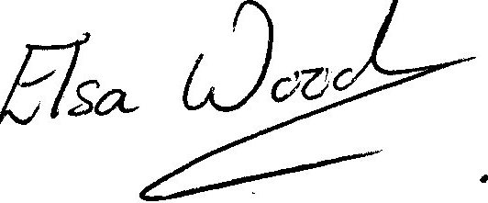

Elsa Wood
Chairman FWC

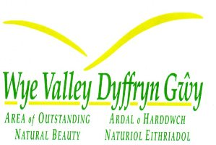

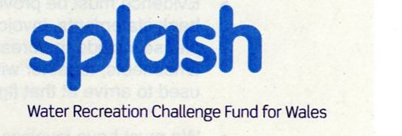

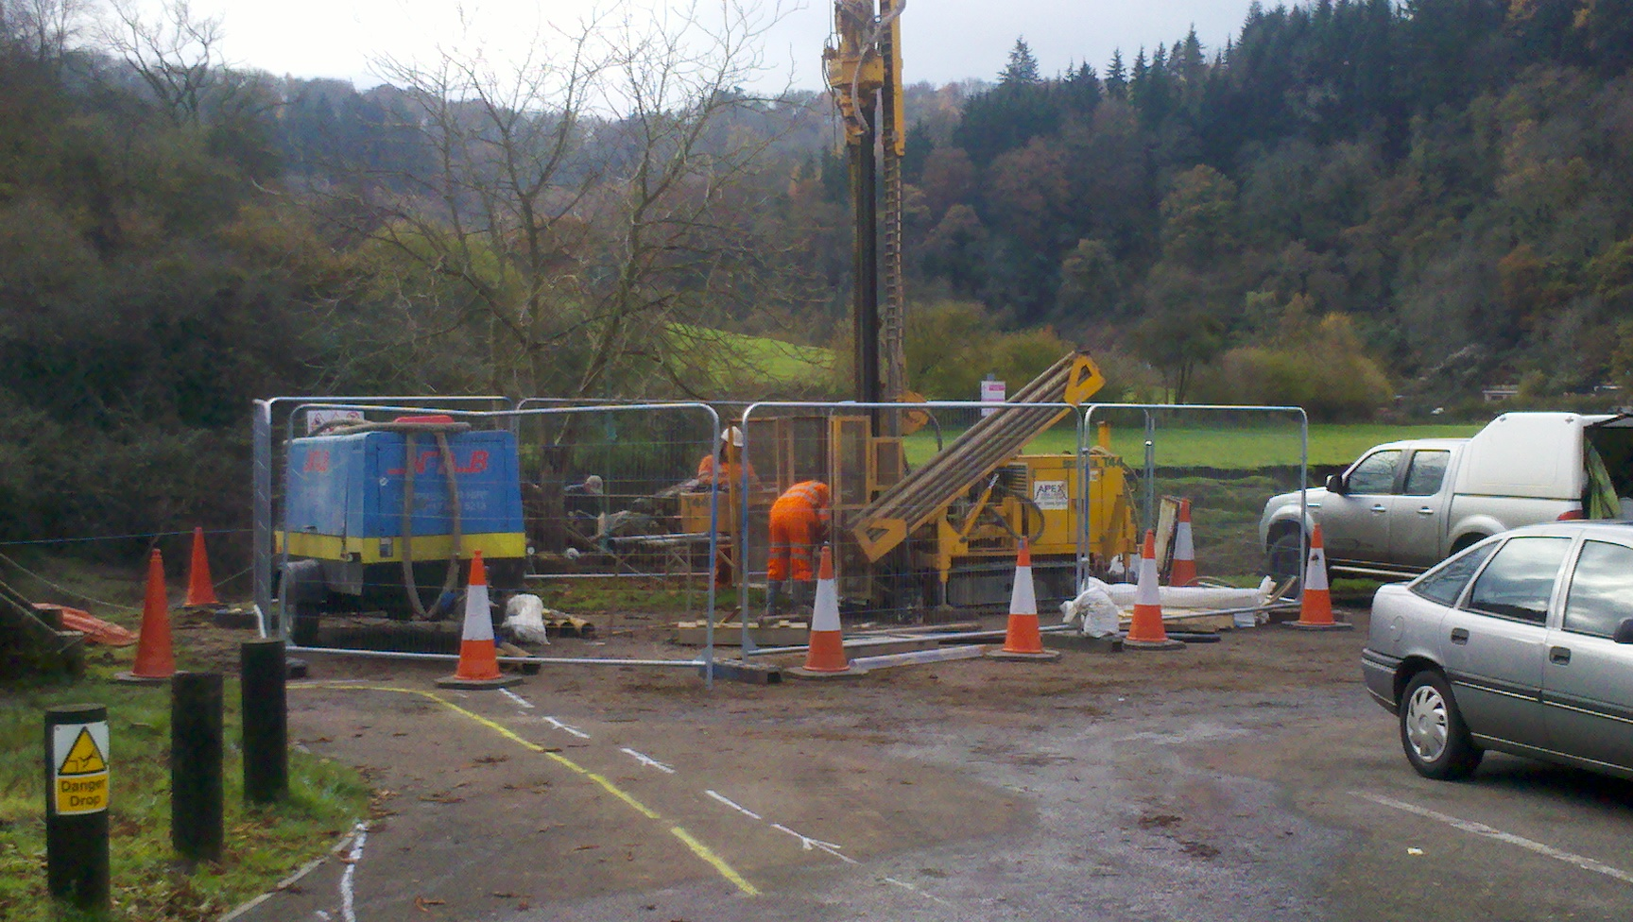
Drill rig in position in the car park

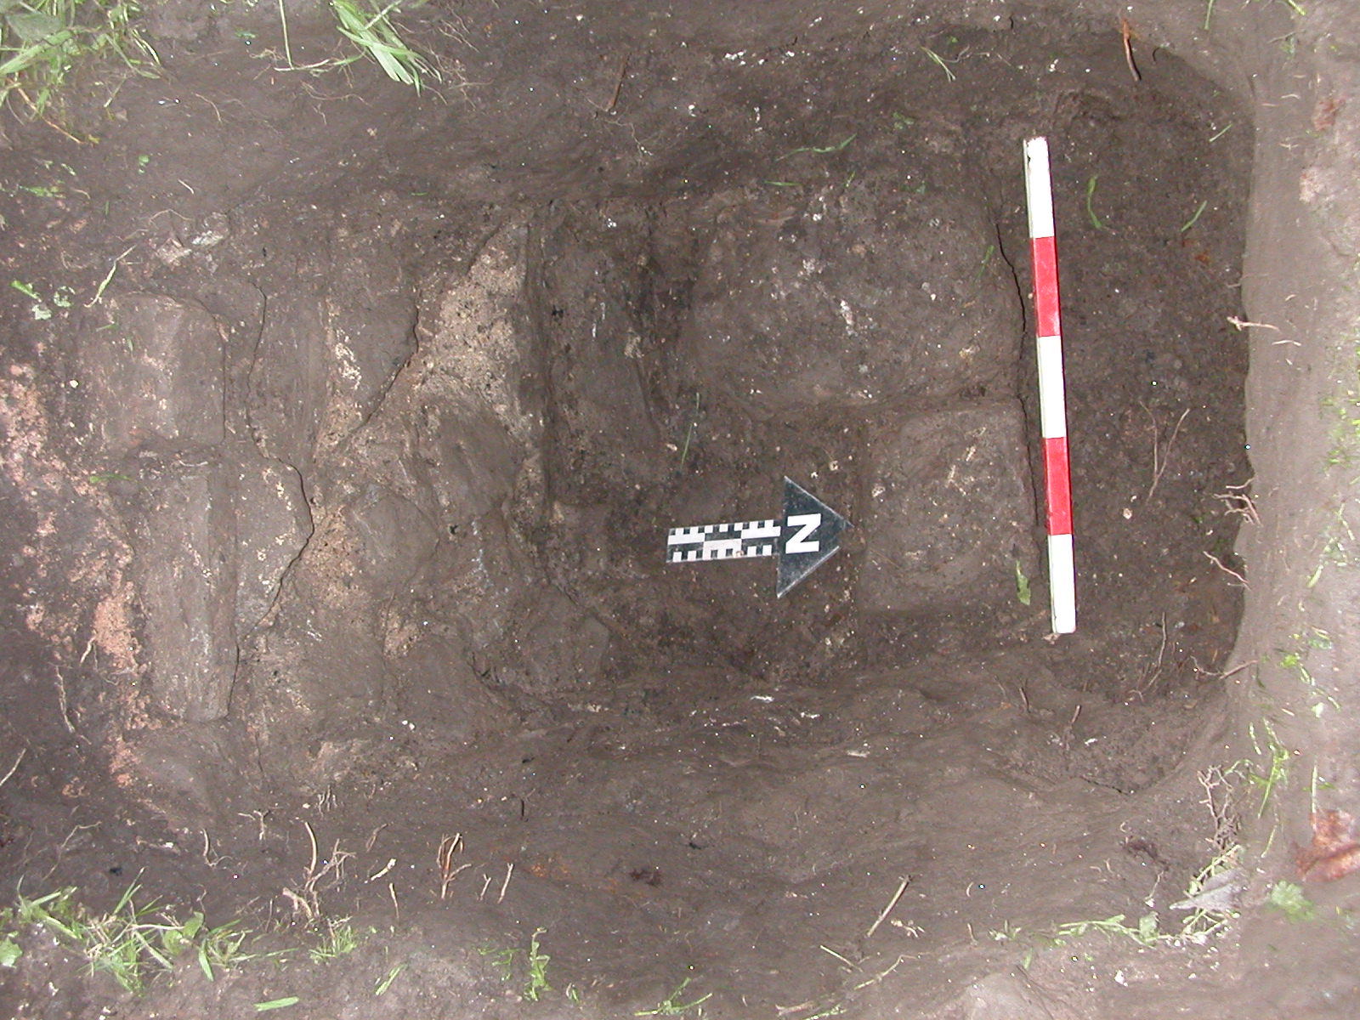
Archaeologist’s trench in the church yard against the wall between the slipway and church ground
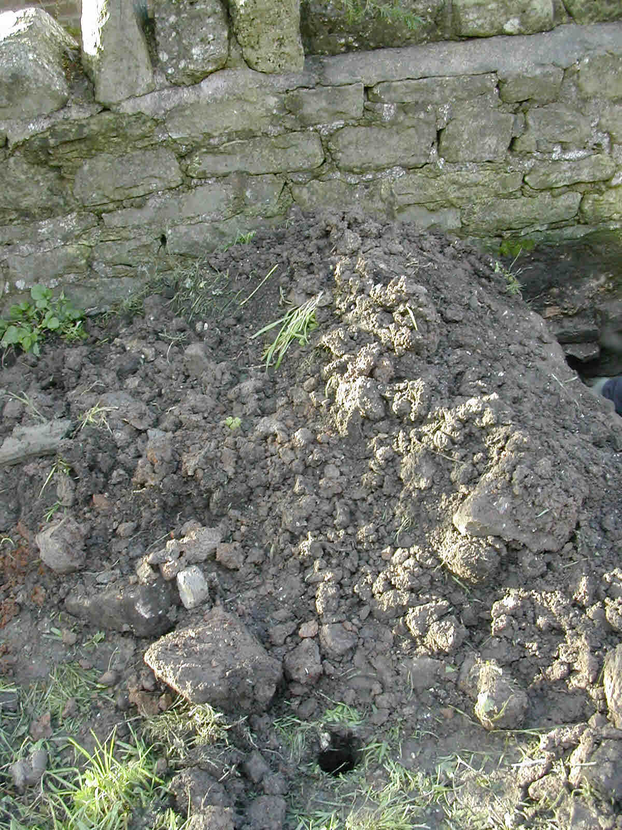
One of the bore holes in the church yard to 3.5m (approx)

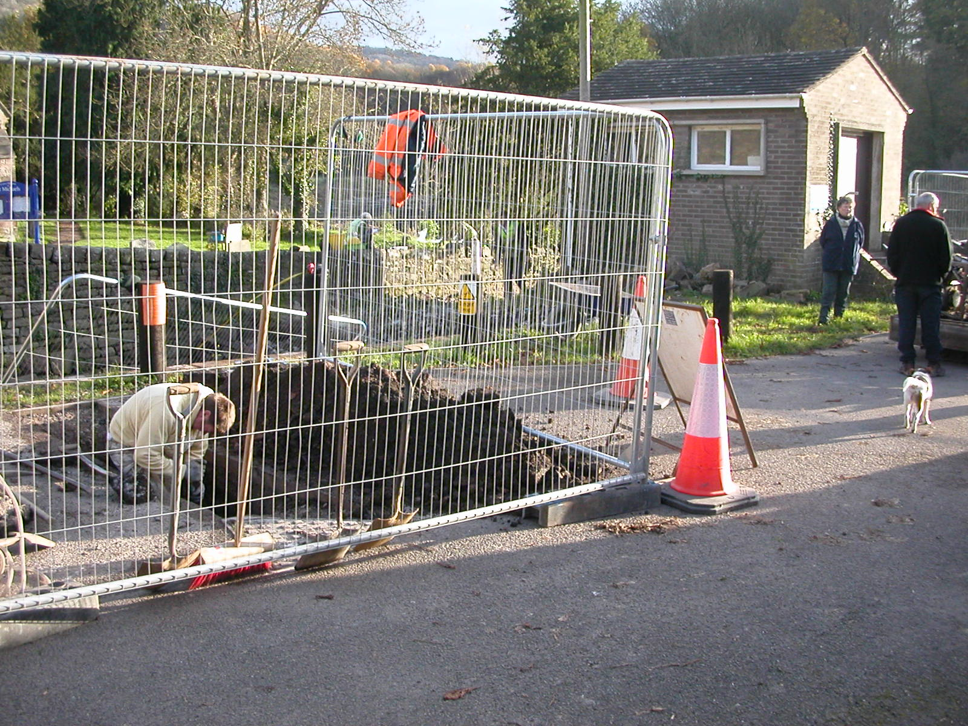
Trench in the car park to trace the services ‘pipes’ etc.

