Ref; LT/ NGT/ 20110/12

3rd July 2012

Pam Lloyd
New Grove Trust
Trellech
Monmouthshire
NP25 4AF

Dear Pam Lloyd

I am writing with a brief report on the kind donation of £2000 your trust gave to Forest of Dean Citizens Advice Bureau in May 2011.

The grant enabled us to purchase software to update all our computers to be compliant with the installation of Petra and purchase a server to enable us to move from a peer to peer network. This will mean that our systems will run faster and more smoothly and has improved security and data assurance. This means that we can look up information more efficiently, use soft ware such as Welfare Benefit calculator packages and Debt Management soft ware more efficiently. Last year the Bureau saw in excess of £3000 clients.

I attach a few photographs showing the computers in use.
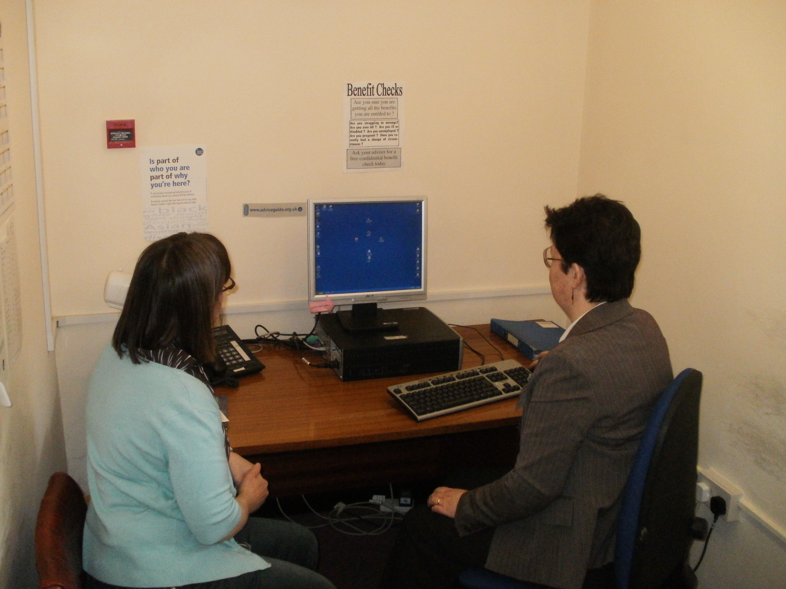
Interview room one 1 A typical interview room – an advisor looks up the information with a client (please note this picture is posed by staff)
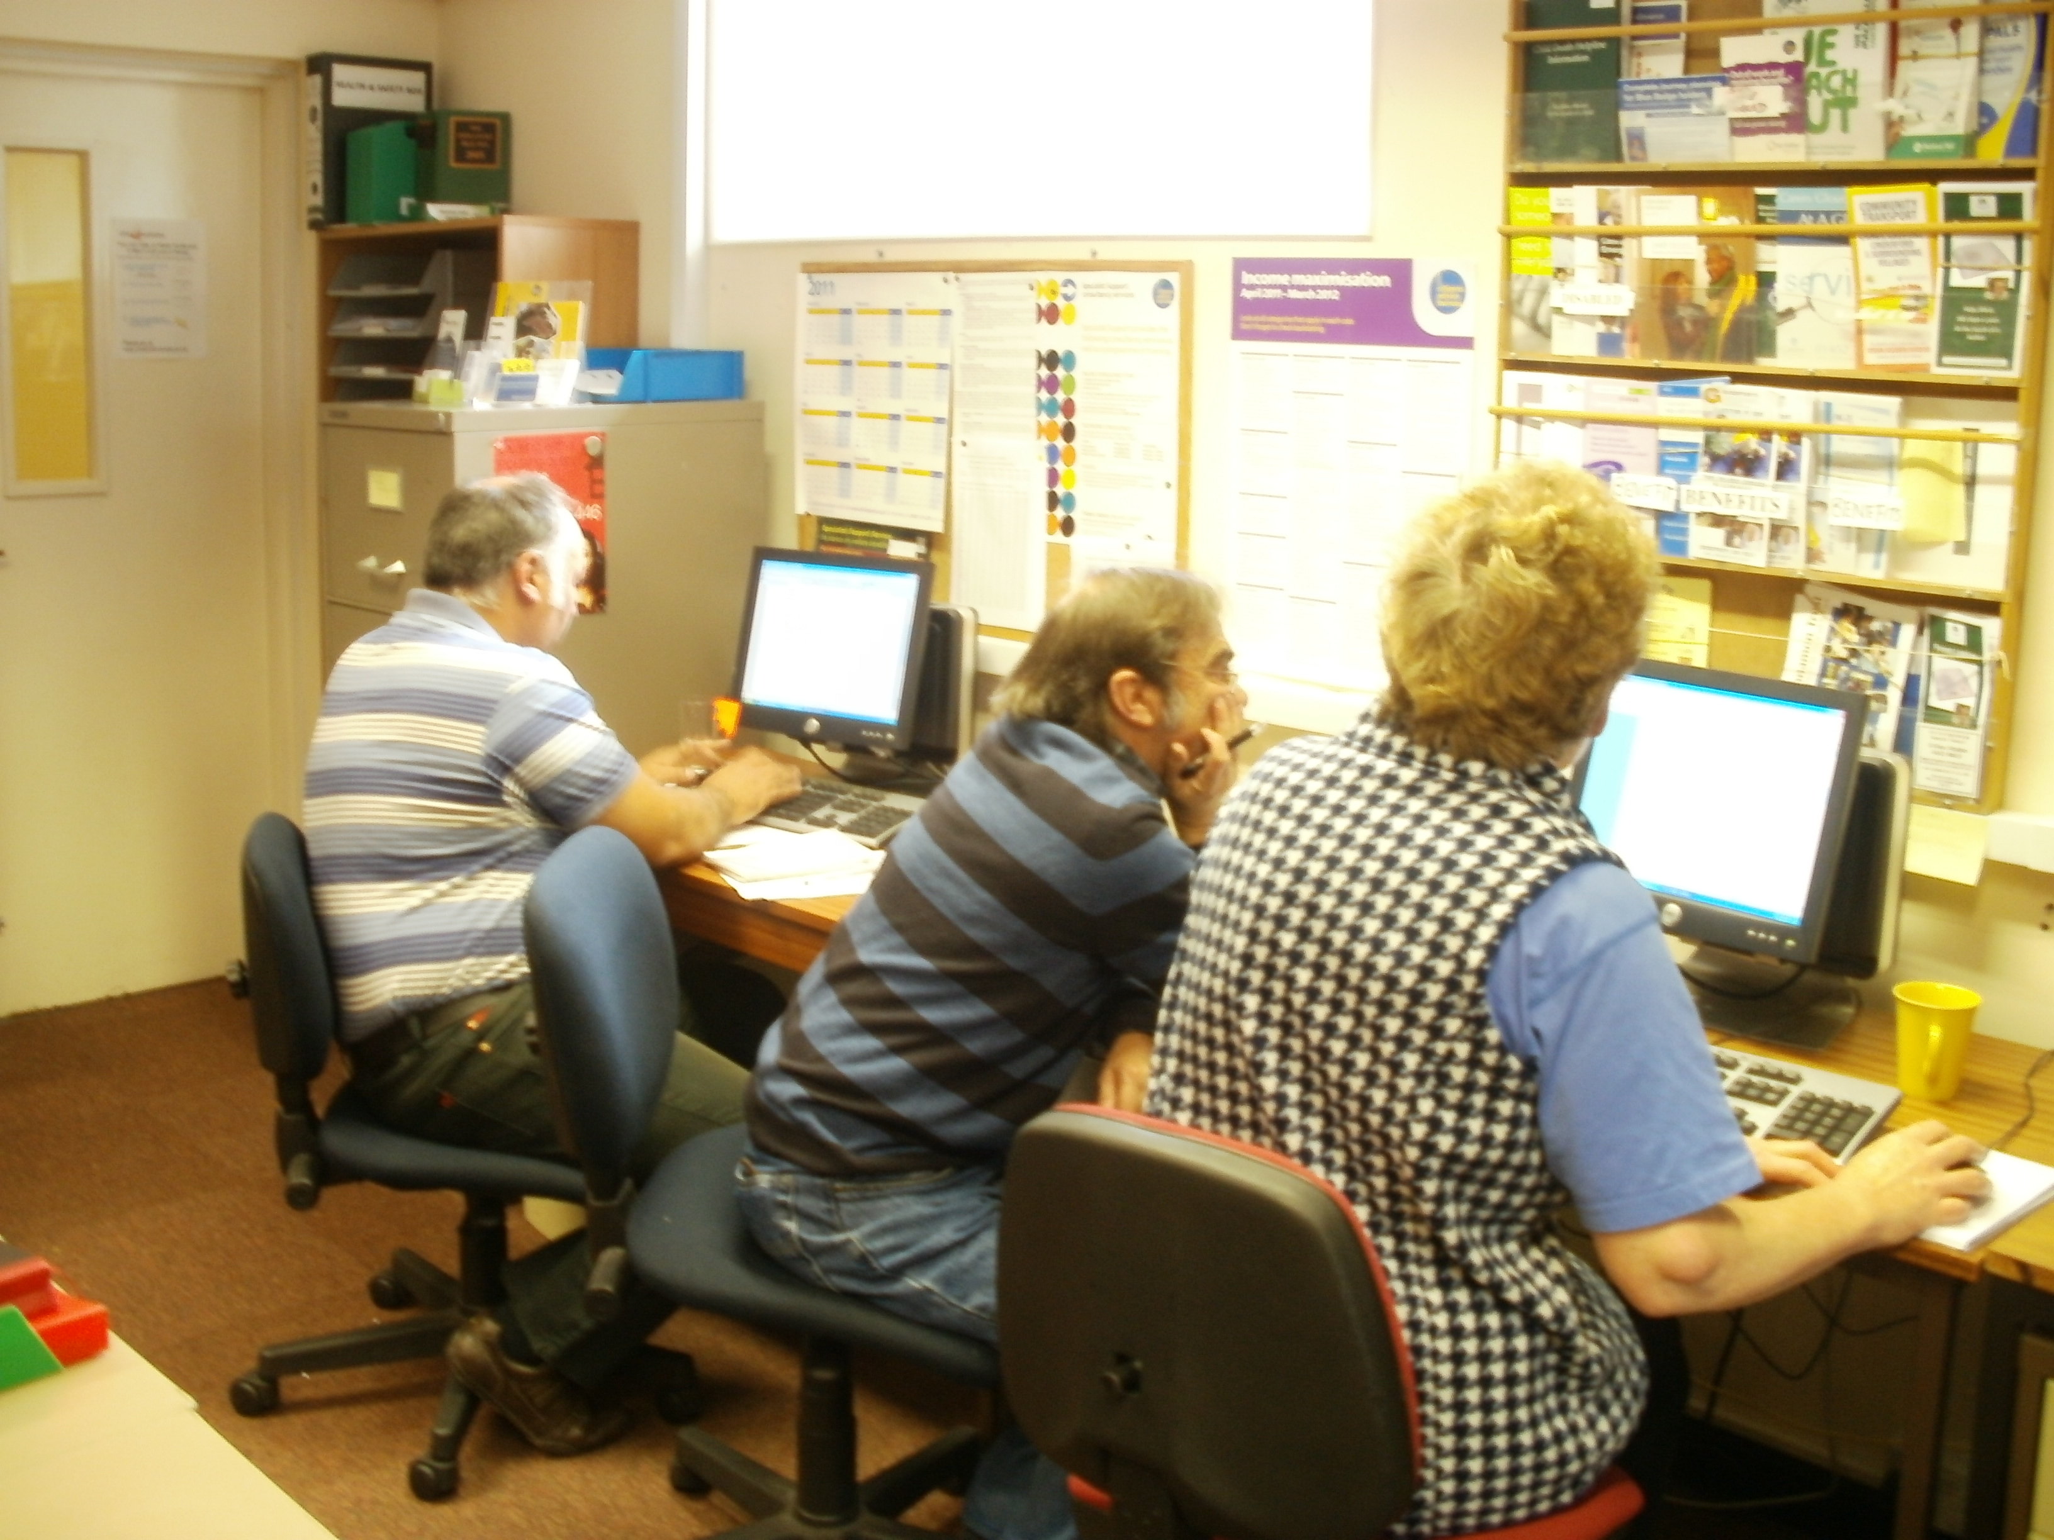
Resource room this is where volunteers type up their case notes, look up information and have support. We often have 6 advisors on in one advice session. They are supported by an Advice Session Support Worker.

I hope this is useful for you. Please contact me if you require further information or help.

Once again on behalf of the volunteers, staff and trustees of Forest of Dean Citizens Advice Bureau I send a huge thank you for your kind donation it is very much appreciated and as you will see put to good use.

Yours sincerely

Lynn Teague
Manager

