By e-mail
Our Mission:
To champion the conservation of plants and fungi in the wild

Our Vision:
A world that values wild plants – now and for the future

Our Goal:
To halt loss of wild plant diversity.

1 April 2015

Mrs P H Lloyd
New Grove Trust
New Grove Farm
Trelleck Road
MONMOUTH
NP25 4AF

Dear Pam

Re: A Report on the Joan’s Hill Woodland Management Project
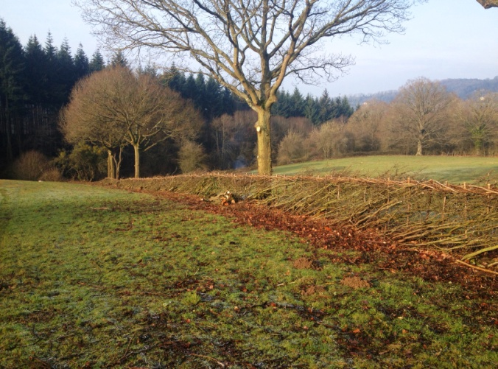
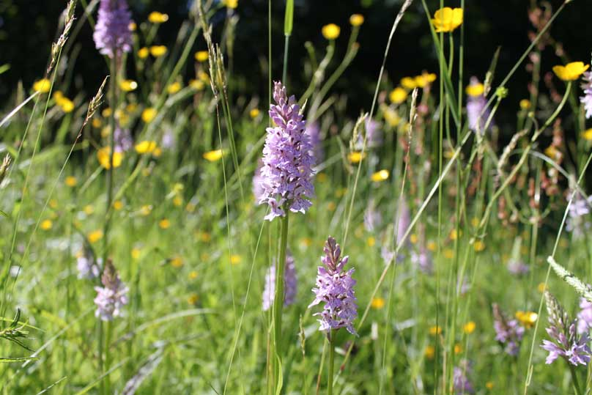
Left: Common spotted orchids in meadow; Right: Hedge laying, with view towards woodland
In August 2014, the New Grove Trust kindly donated a grant of £1,000 towards our Joan’s Hill Nature Reserve woodland project. I would be grateful if you could pass the report below to your trustees. I am also including some photographs, as promised.

We asked for support for the initial costs of establishing best-practice management within the small wood that is part of Plantlife's Joan's Hill Farm Nature Reserve, in Checkley, Herefordshire. The wood is immediately adjacent to the extensive Haugh Wood Site of Special Scientific Interest that is owned and managed by the Forestry Commission.

As an assart to Haugh Wood, the 2-acre wood at Joan's Hill Farm is of significant interest because of its different management history, and because it comprises a relatively natural woodland type that has not been altered by planting. Our vision is to establish the wood as an example of best-practice so that it will form a useful resource to inform the management of other small woods in the area. To achieve this, a comprehensive baseline of biological data is required so that the impact of future management work can be assessed.

Much of this baseline data has already been collated, but some groups including lichens, bryophytes and invertebrates require us to commission surveys from relevant experts. The grant, along with funds from other trusts, has helped us to commission surveys of these groups, and to establish transects for scientific monitoring of the ground flora.

As a direct result, I am pleased to report that a rare moss has been discovered at Joan's Hill Farm. We commissioned a bryophyte survey in October 2014, made possible by your grant, which has resulted not only in important baseline data, but also in two particularly exciting discoveries. On the same tree in our small wood, the surveyor found Orthotrichum acuminatum and Orthotrichum rupestre. The former has only been recorded once before in Britain (in Derbyshire, where it has since gone extinct), and the latter is also notable, having been recorded at only one other site in Herefordshire. The range of these species is thought to be expanding - perhaps because of climate change.

I am also pleased to report that we have recently installed the planned pedestrian gate (pictured below) within the wood’s perimeter fence so as to facilitate public access, allowing visitors an opportunity to explore our wood as well as our meadows.
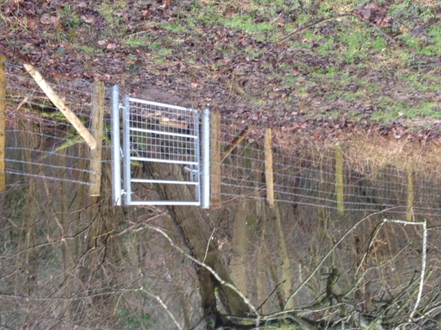

Our Reserves Manager, Joe Costley, has discussed our woodland management proposals with two skilled local woodsmen. One of these (Dave Jackson of Wildwood Coppice Crafts) is keen to undertake the practical woodland work – opening the canopy allowing more light to reach the woodland floor for the benefit of ground flora. Dave has been very busy with hedge-laying work (also at Joan’s Hill and pictured on page 1), over the past winter, and will therefore aim to commence tree thinning within the wood in the autumn / winter of 2015/16.

We very much appreciate the grant which has helped with this particular project.

Yours sincerely

Claire Perrens
Project Development Officer
claire.perrens@plantlife.org.uk
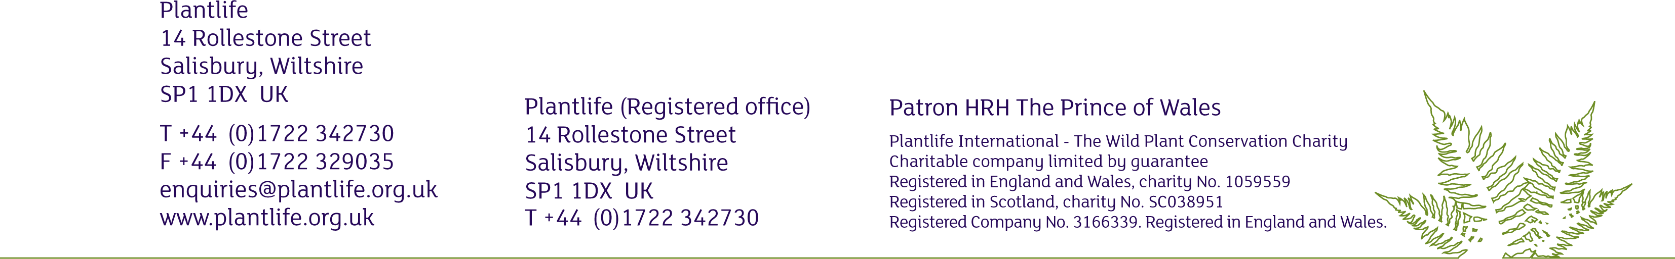
T: 01722 342751

Page 2/2

